Yield: 6 servings

Prep time: 20 minutes

Total time: 40-50 minutes

Golden Beet and Fennel Soup

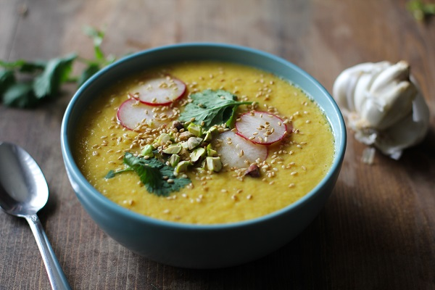

INGREDIENTS

extra-virgin olive oil |3 Tablespoons

yellow onion | 1, diced

carrots | 2, peeled and diced

fennel bulb| 1, diced

fresh ginger | 1 Tablespoon, grated

golden beets | 1 lb, peeled and diced

Magic Mineral Broth* | 6 cups

orange zest | ½ teaspoon

freshly squeezed orange juice | 3 Tbsp

fresh mint* | 1 Tablespoon, chopped

NOTES
- See recipe for Magic Mineral Broth
- Mint is optional for garnish

Julie’s Tip: “I love golden beets compared to red because they are sweeter, mellower, and no mess! In the winter you can find Jessica’s F.M., Whole Foods, and often Publix.”

- Pour the soup back into the pot, heat gently, and stir in the orange zest, orange juice, and lemon juice.
- Taste – you may want to add a pinch more salt.
- Serve garnished with mint if desired (store in airtight container in the frig for up to 5 days/freezer 3 months)

ABOUT THIS RECIPE:

Gluten free, Dairy Free, AIP Diet, Anti-Candida, Anti-Inflammatory, Vegetarian

DIRECTIONS
- Heat the olive oil in a soup pot over medium heat, then add the onion, carrots, fennel, and 1⁄2 tsp. salt and sauté until golden, about 6 minutes. Stir in the ginger and beets and sauté until well combined and well coated.
- Pour in 1⁄2 cup of the broth to deglaze the pot, stirring to loosen any bits stuck to the bottom,
and cook until the liquid is reduced by half.
- Add the remaining 5 1⁄2 cups of broth and another 1⁄2 tsp salt. Bring to a boil, then cover and simmer until the beet are tender, 20-30 minutes.
- In a blender, puree the soup in batches until very smooth, each adding the cooking liquid first then the beet mixture.

